**Local-site**



**Visual  
display**

**Tactile displays**

**Barriers**

**Remote-site**

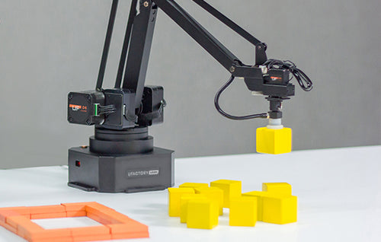

**Teleoperator**

**Actuator**

**Sensor &  
End Effector**

**Environment**

**Local-site**

**Hand Gestures**

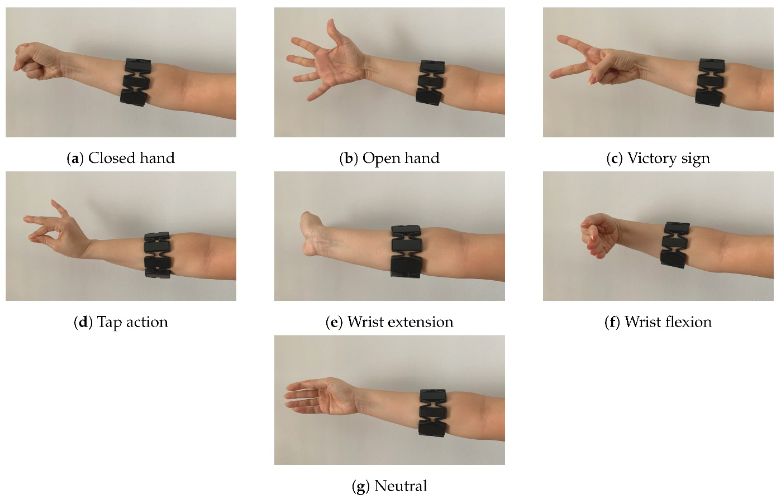

**RAW EMG Signal**

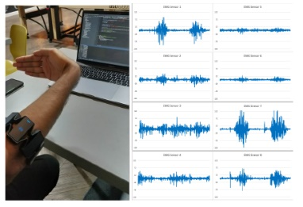

**Signal Pre-processing**

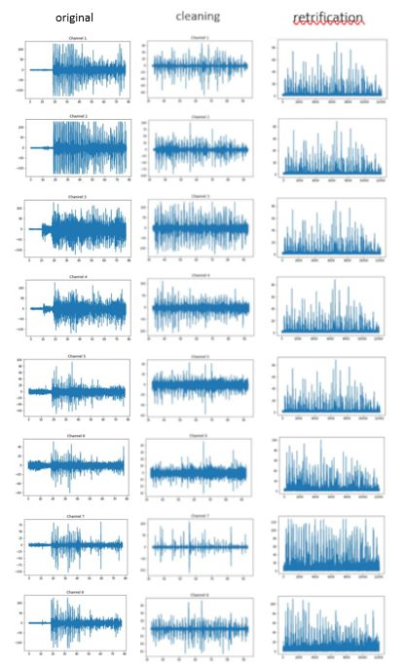

**Feature Extraction**

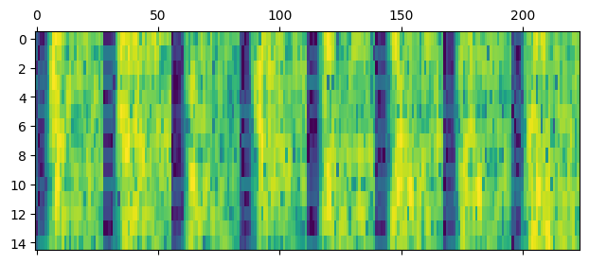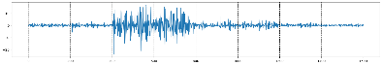

**GRU Classifier**

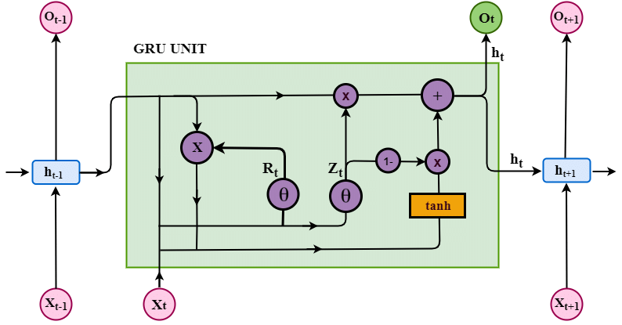

**RAW IMU Signal**

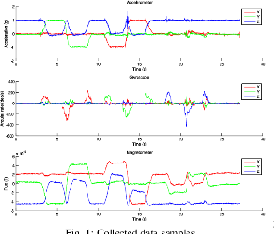

**Angel Conversion**

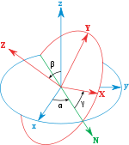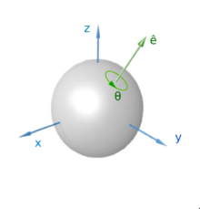

**Robot Control**

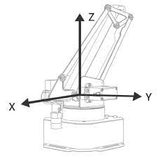

**Remote-site**

**Polar or Cartesian coordinates**

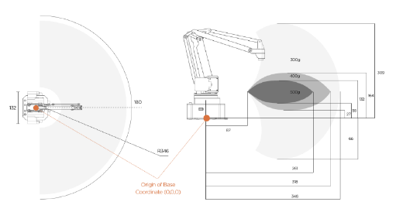

**uArm Robotic Arm**

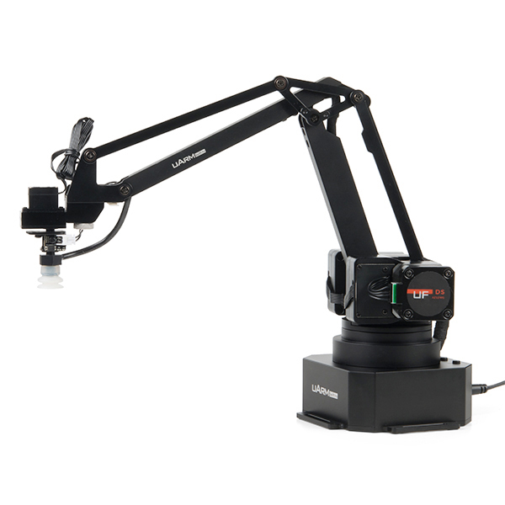

**End Effector**

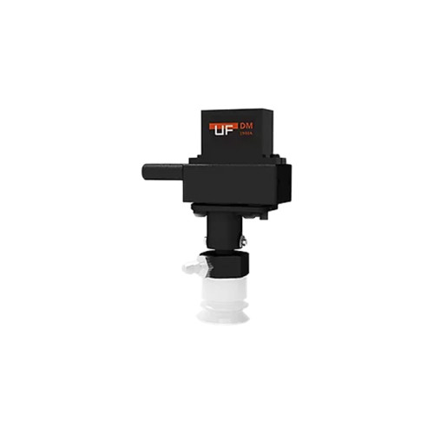

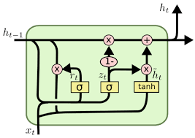

**Reset gate**

**Update gate**

Multi-Head Attention Transformer is a type of attention mechanism that can performing a linearly project the queries, keys and values $\mathnormal{h}$ times with different, learned linear projections to $\mathnormal{d_q}$, $\mathnormal{d_k}$ and $\mathnormal{d_v}$ dimensions, respectively~\cite{Vaswani2017article}. The processed start by splitting the input sequence into $\mathnormal{h}$ parts and applying attention mechanism to each of the parts. Each part has queries (Q), keys (K) and values (V) vectors that are learned during training. These vectors are used to linearly project the input sequence into different dimensions ($\mathnormal{d_q}$, $\mathnormal{d_k}$ and $\mathnormal{d_v}$). Therefore, multi-head attention can capture more complex relationships between different parts of the input sequence.



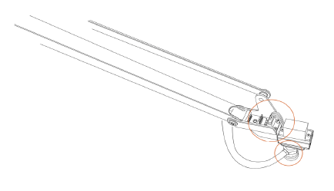

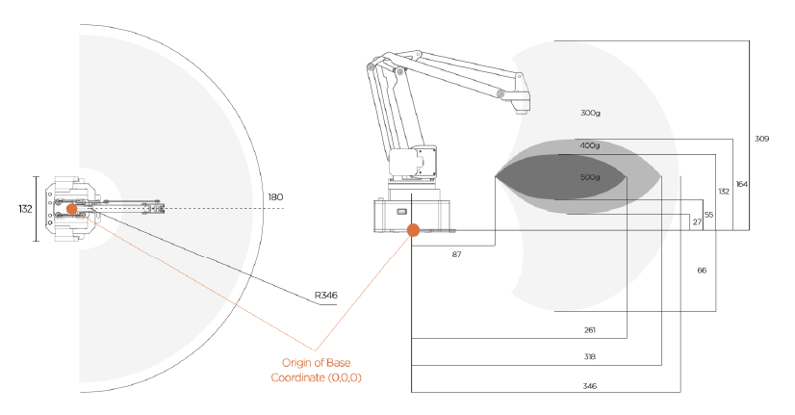

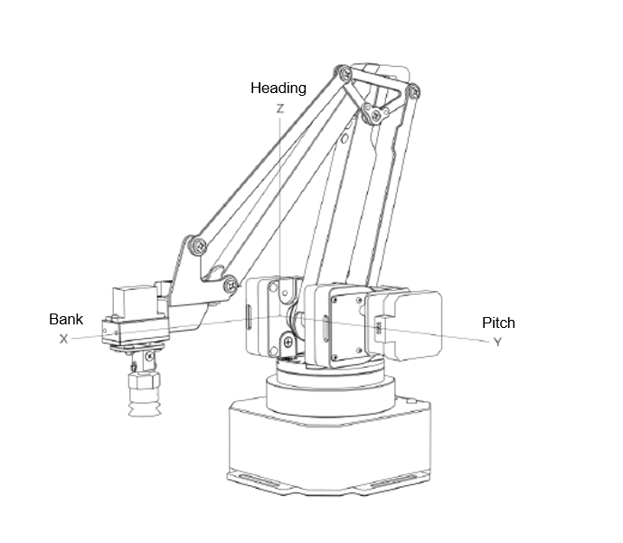

This dataset was collected by Dolopikos et al. for their experiment []. They used a Myo armband connected to a computer via Bluetooth Low Energy (BLE). Myo Hub SDK was used to gain access between Myo armband and Python to record the EMG signal. There were fifteen participants in the experiment (9 male and 6 female), and participants ranged in age from 26 to 52 years. The participant would wear the armband on their right forearm,m and they were required to make four gestures: a closed fist, spread open finger, waving inwards, and waving outward. The participant would perform a single gesture for 60 seconds repeatedly, and this was repeated for five consecutive repetitions for each gesture. The EMG data collected was streamed at 200Hz, and each measurement season was saved in a signal.csv file. There are 300 samples in the dataset, and only the RAW dataset is used.

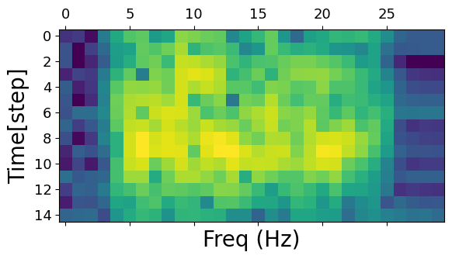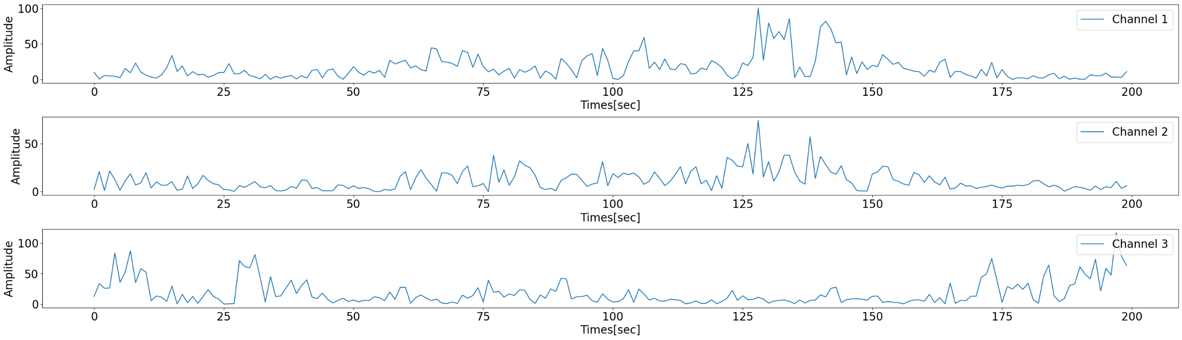

Windows 2

Windows 3

Windows 1

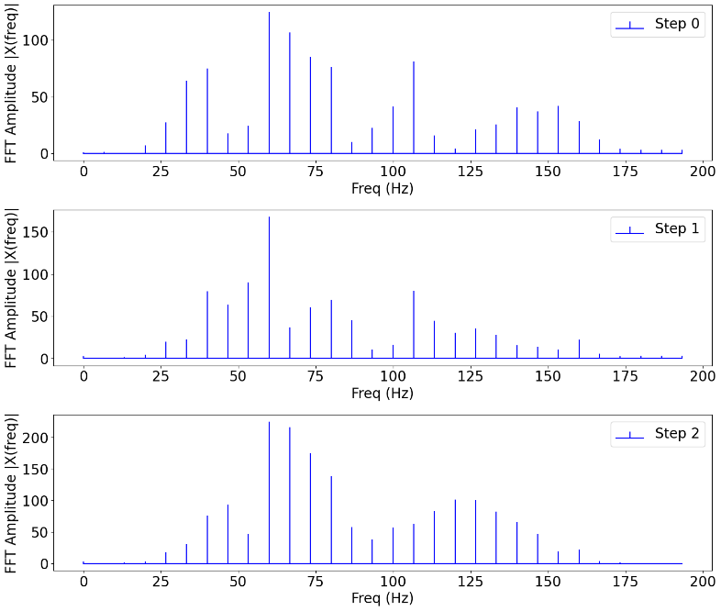



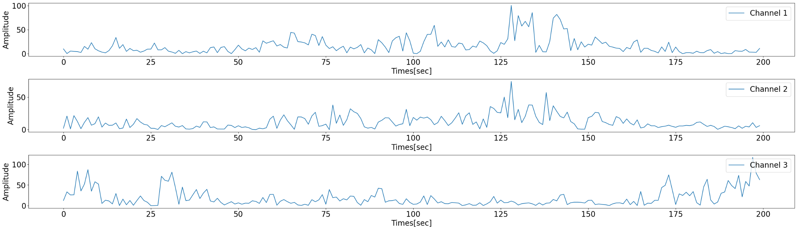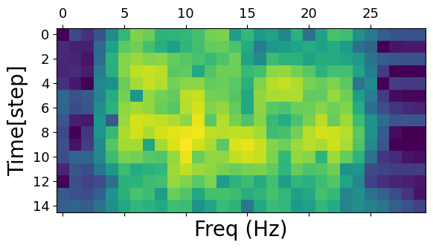

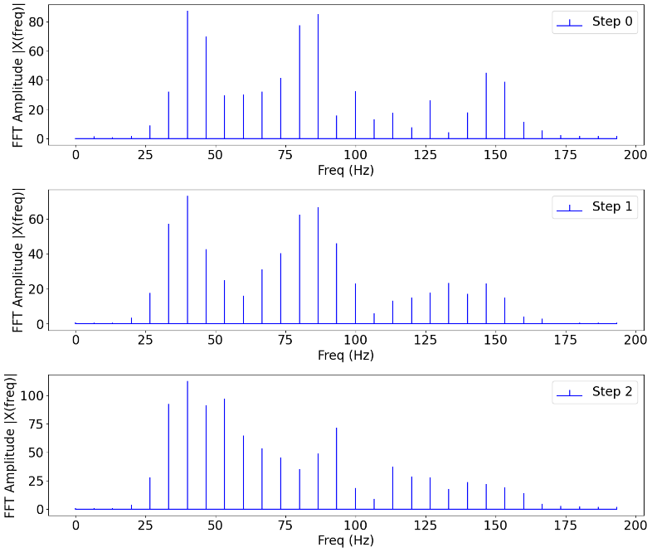

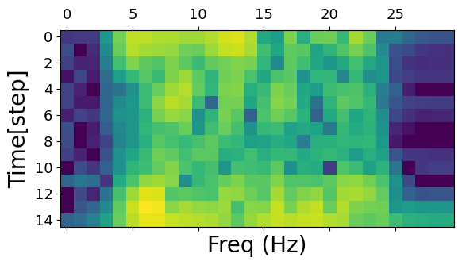

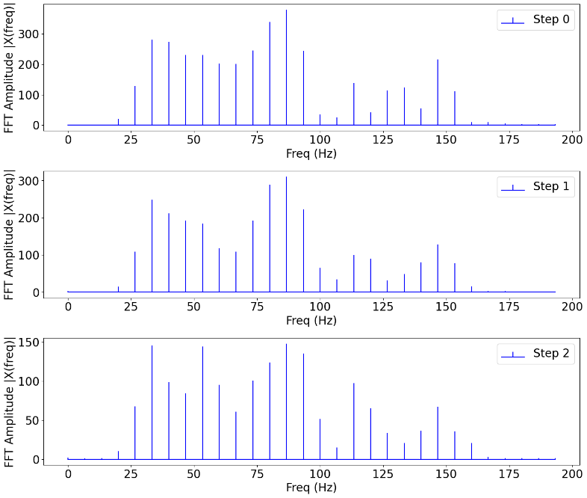

**.  
.  
.**

**.  
.  
.**

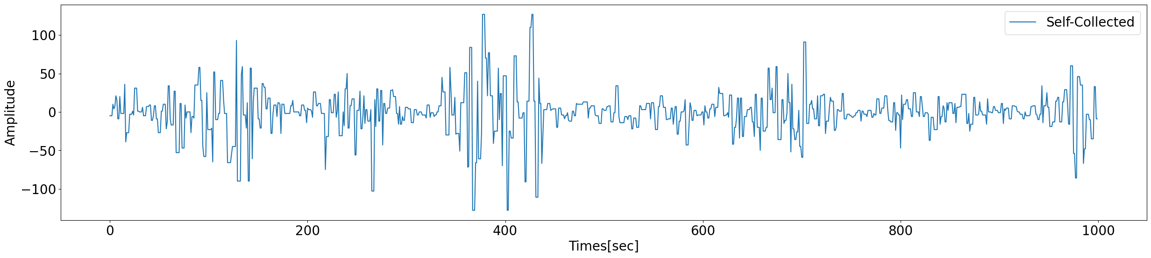

Windows 3

Windows 2

Windows 1

Gesture 1

Gesture 2

Gesture 3

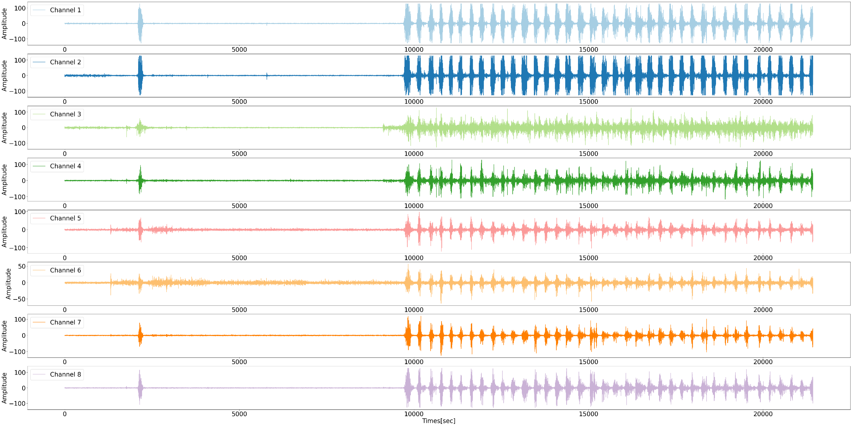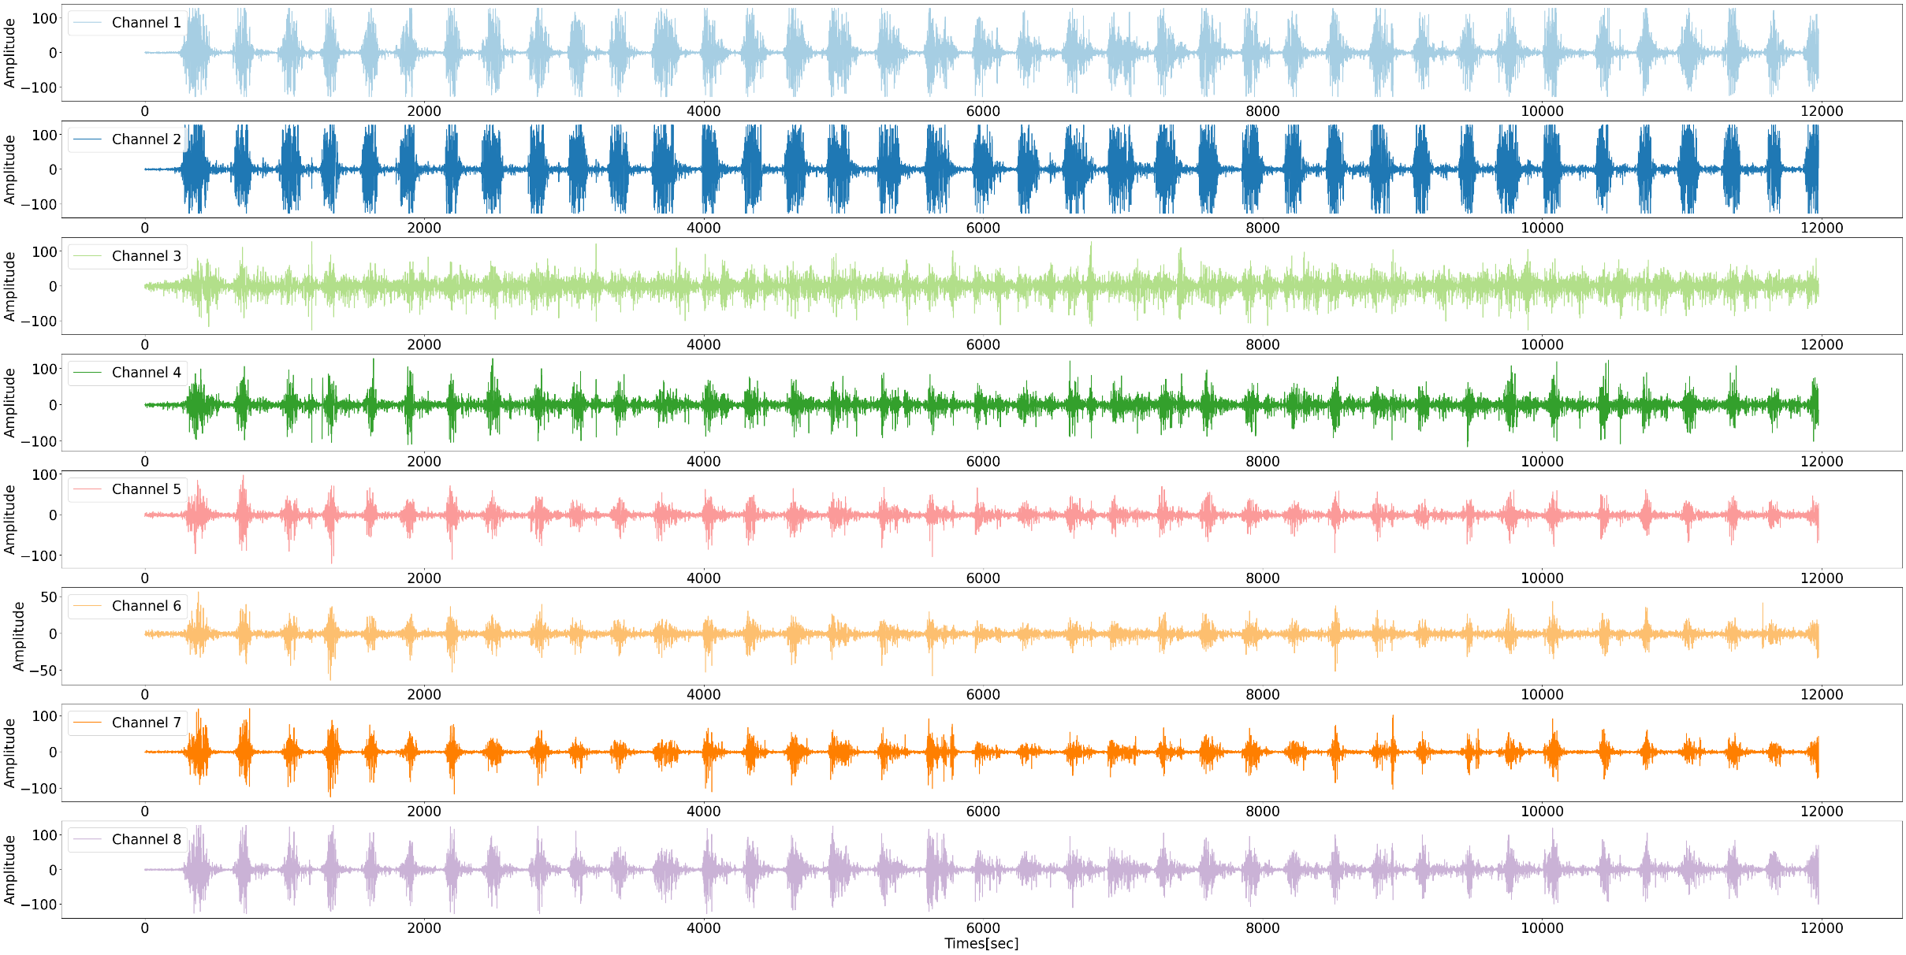

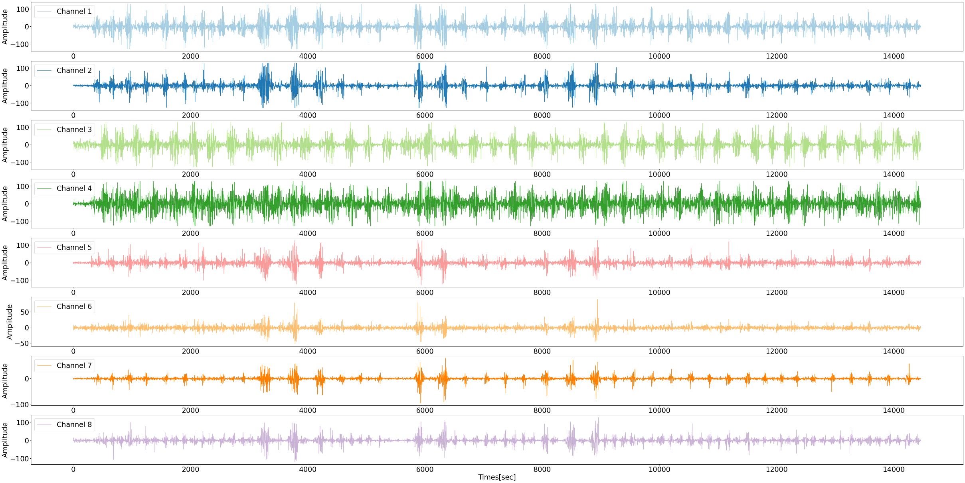

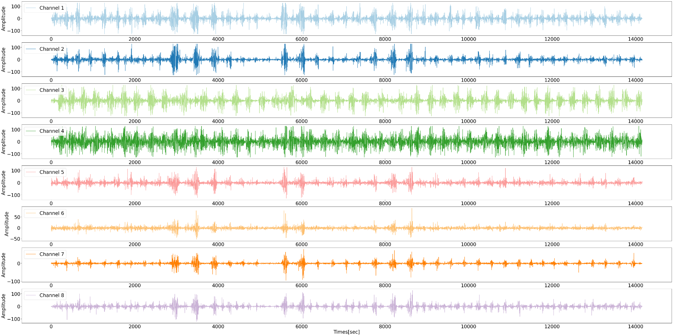

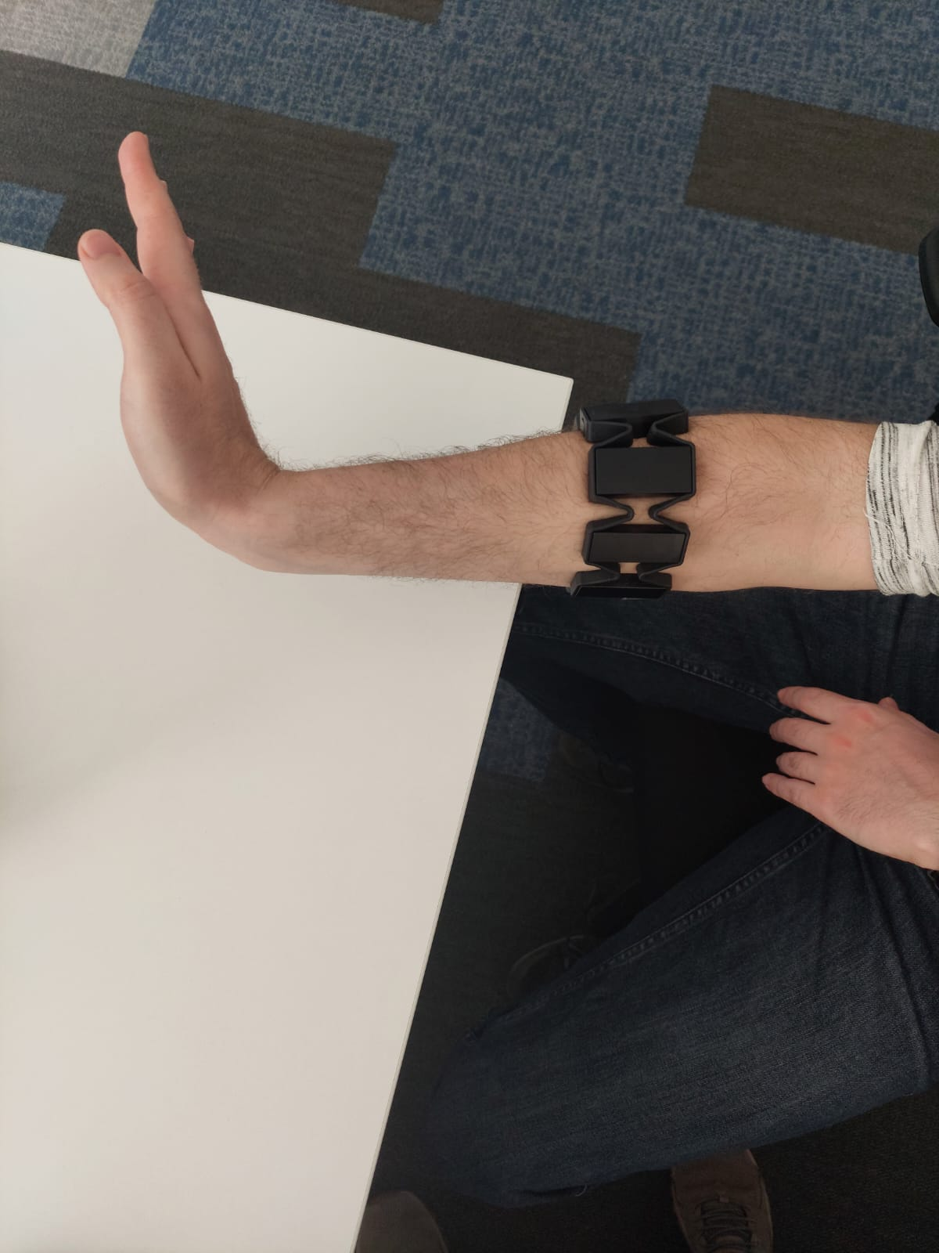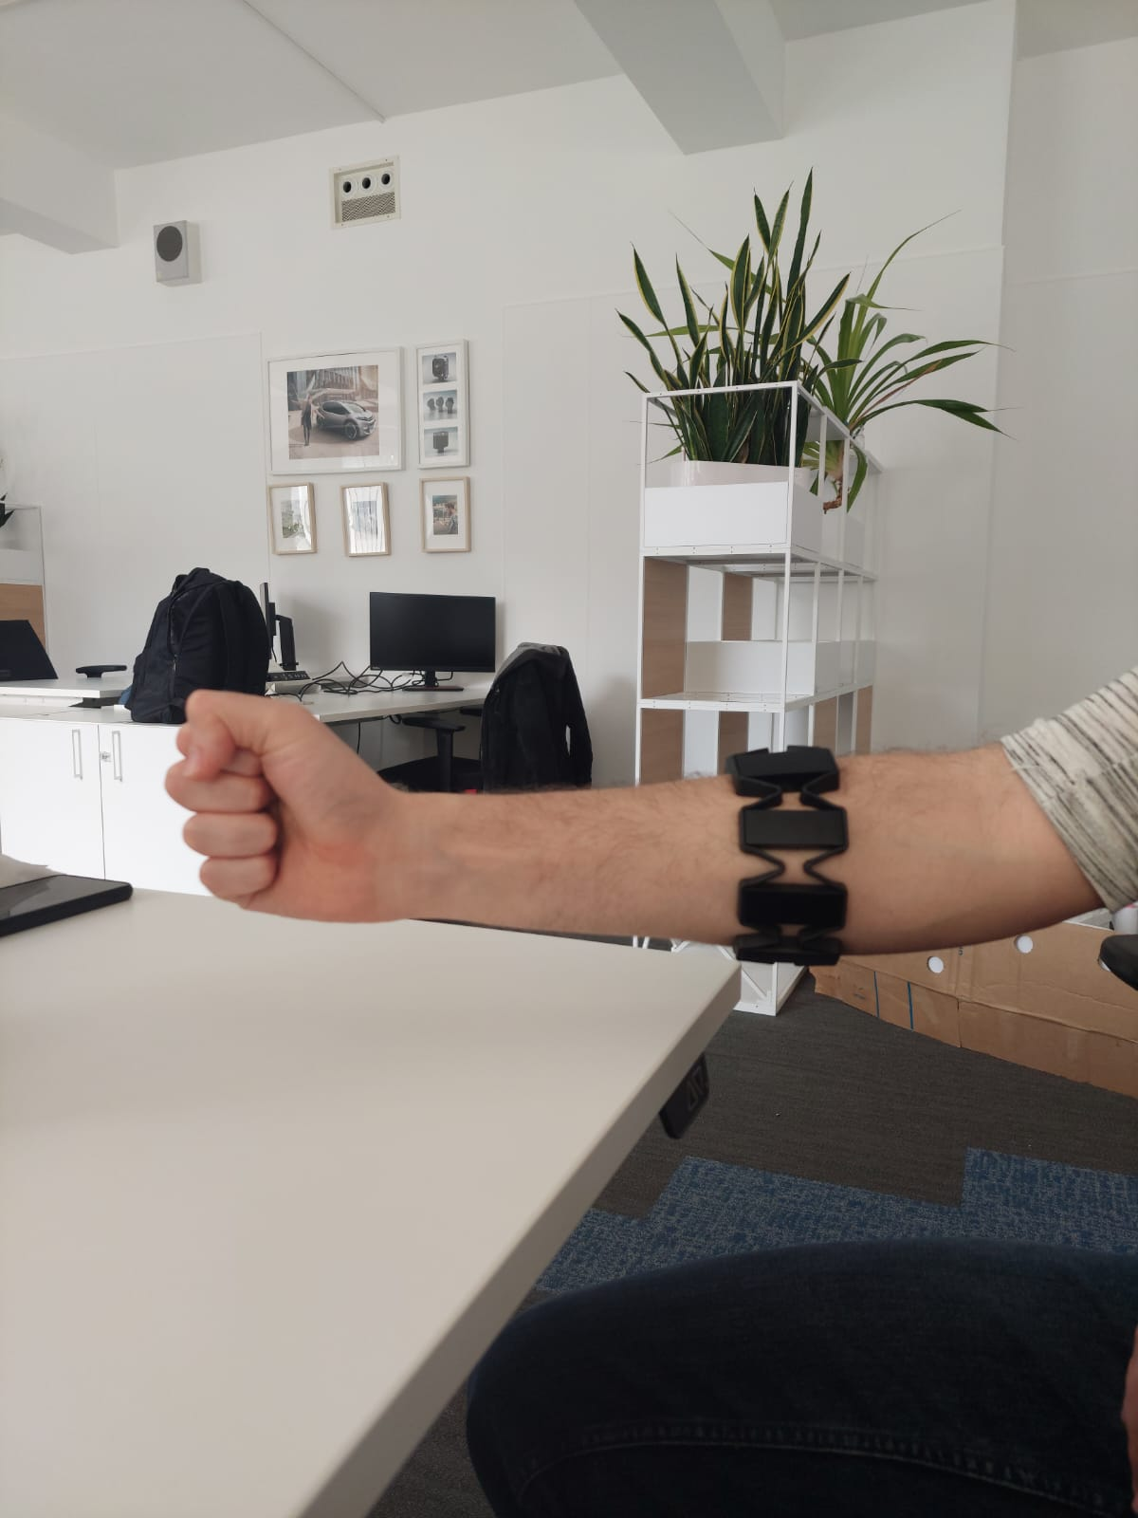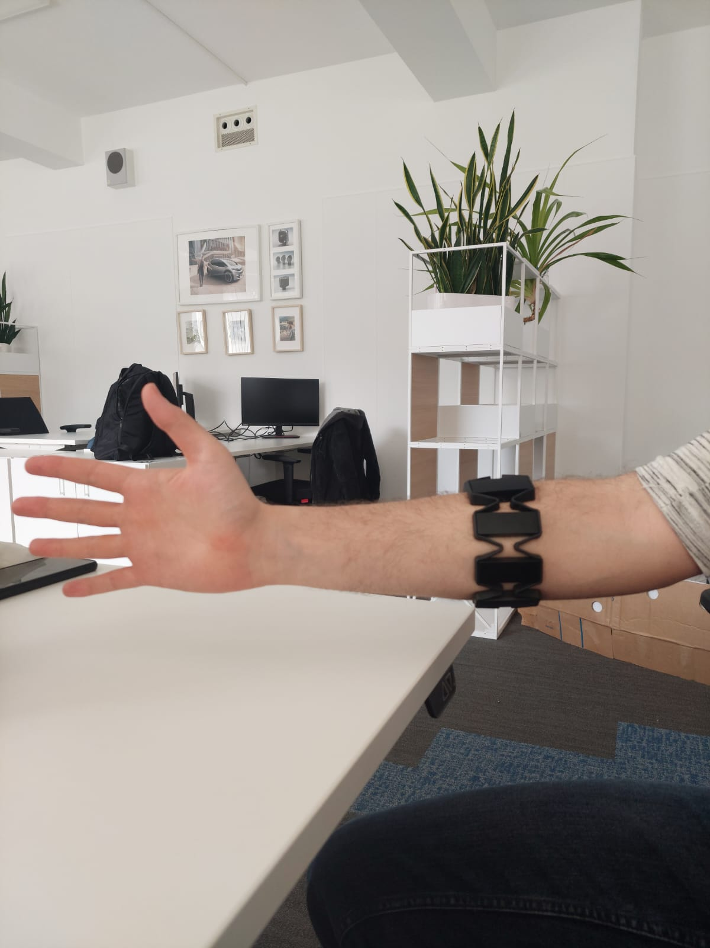

**B**

**A**

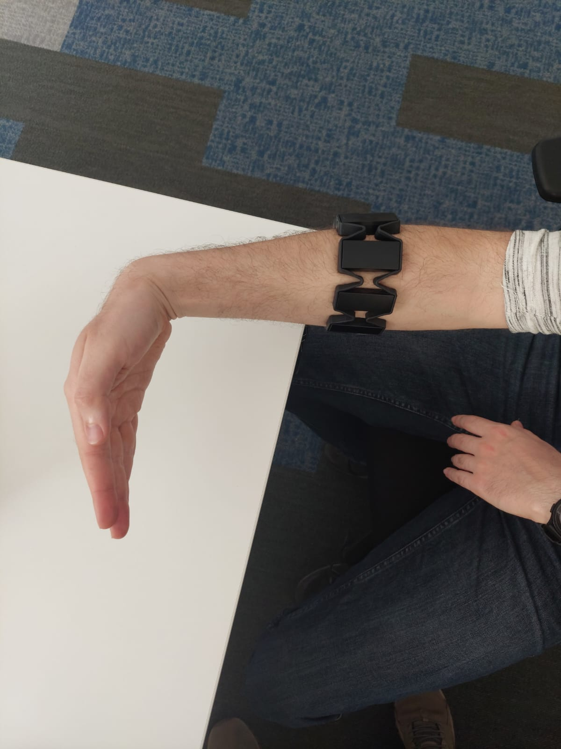

**C**

**D**

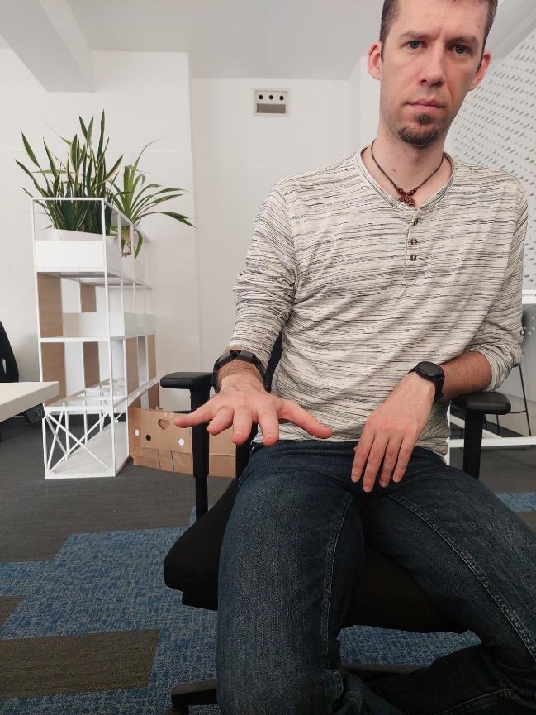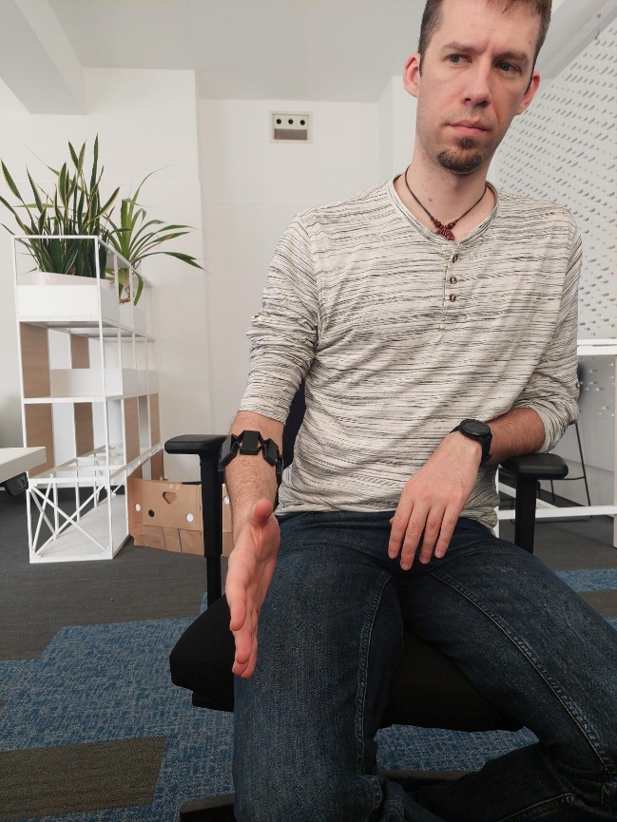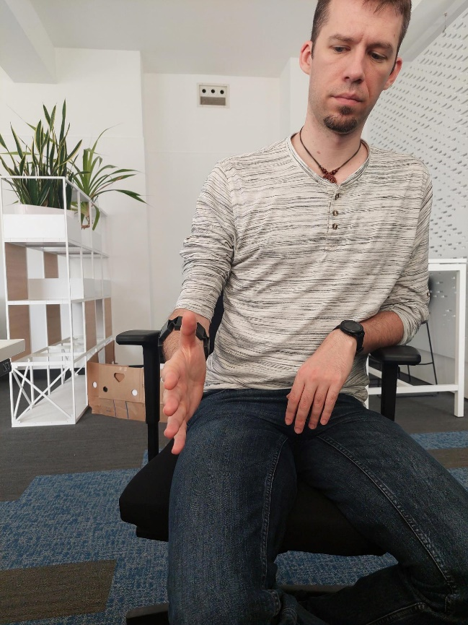

**B**

**C**

**D**

**E**

**F**

**G**

**A**

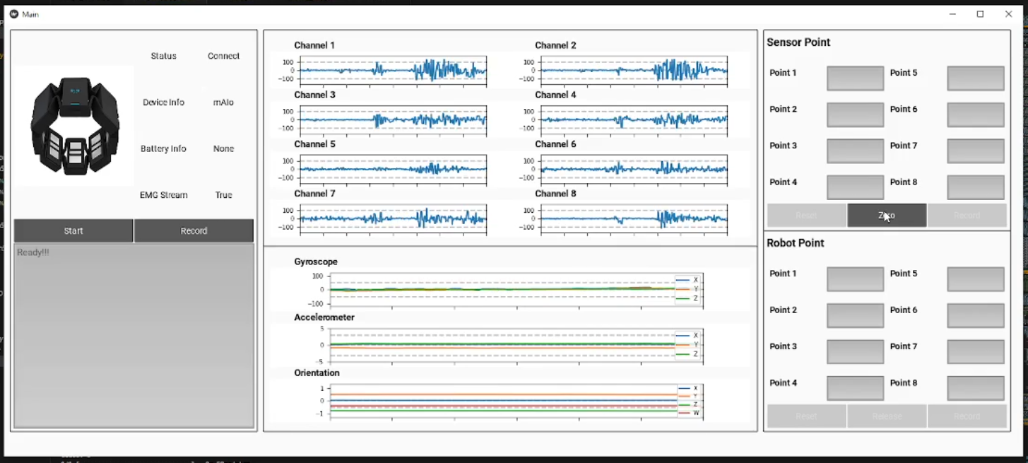

The signal that already divides into small time segments will be analyzed using STFT. The overlapping sliding windows method will be used again in this step but with smaller windows to reduce spectral leakage and provide smooth transitions at the segment boundaries. The forier transform would perform on each signal window and convert the time-domain signal into the frequency domain, providing information about the segment's frequency content. After that, the magnitude of the spectrum would be computed for each segment, representing the distribution of energy across different frequencies. In the end, each window segment's result is combined to create a time-frequency representation of the signal and a spectrogram is used to give a display representation as a 2d plot. Figure 1 illustrates the process of sliding windows going around the signal in each channel and transforming it into a spectrogram.

The proposed model architecture is a deep neural network consists of stacked layers including GRU (Gated Recurrent Unit) and multi-head attention layers designed for classifying EMG signals based on stack spectrograms. The GRU layers capture temporal dependencies within the spectrogram, while the multi-head attention layers enable the model to focus on different parts of the sequence, effectively capturing important patterns. The input to the model is stack spectrograms representing the frequency content of the EMG signals. The model consists of hidden layers with varying numbers of units. Strart with GRU model with 128 units to 64 units with tanh activation function, continue to Multi-Head Attention layer with 32 number of hed and 64 key dimention to 16 number of hed and 32 key dimention. In the end of the model two Dense layer used with 32 units with ReLU activation function and 4 units and Softmax activation function. The Adam optimizer is used with a learning rate of 0.001 to optimize the model's parameters during training. Early stopping is utilized with a patience of 10 epochs to prevent overfitting and restore the best weights based on validation loss. The models performance is evaluated based on categorical cross-entropy loss and accuracy metrics. Figure 1 illustrate the whole model. Experimental results demonstrate that the proposed model achieves accurate classification results, indicating its potential for EMG signal analysis in various applications.

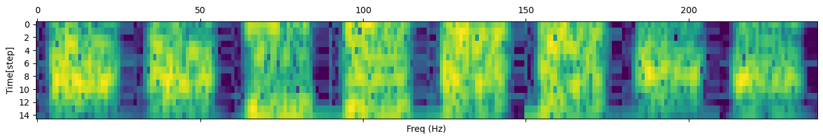

**Input 15x240**

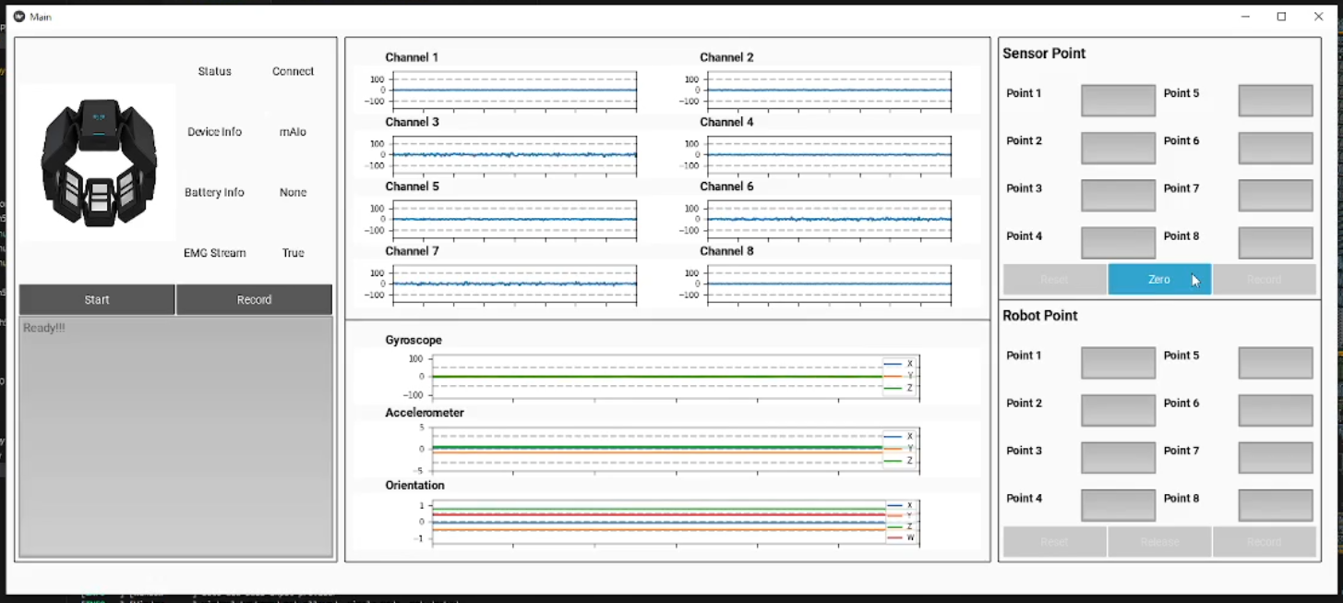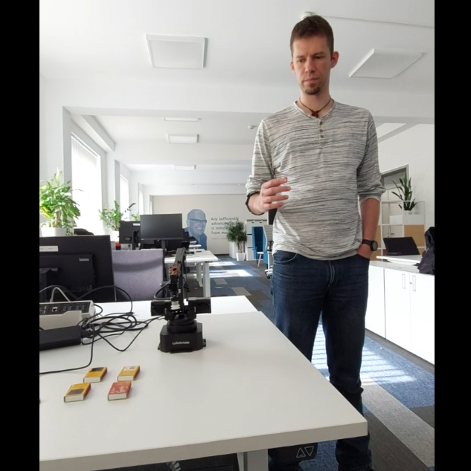

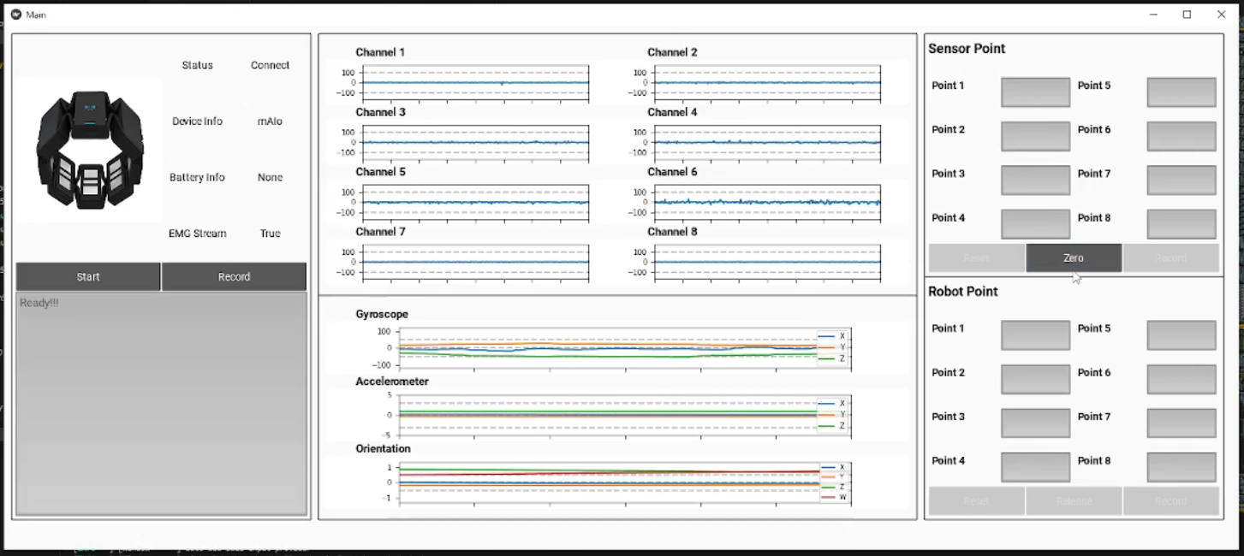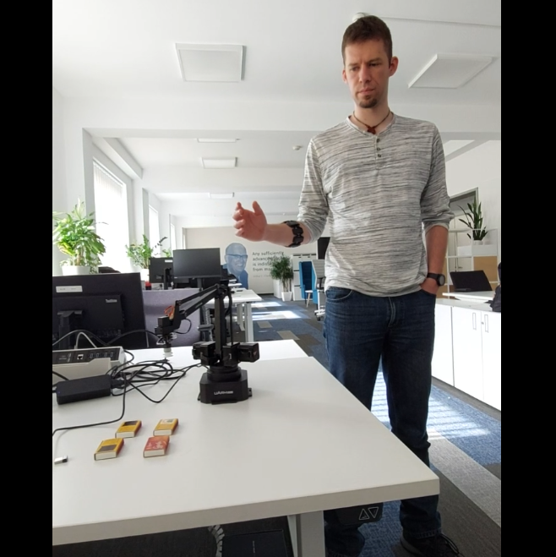

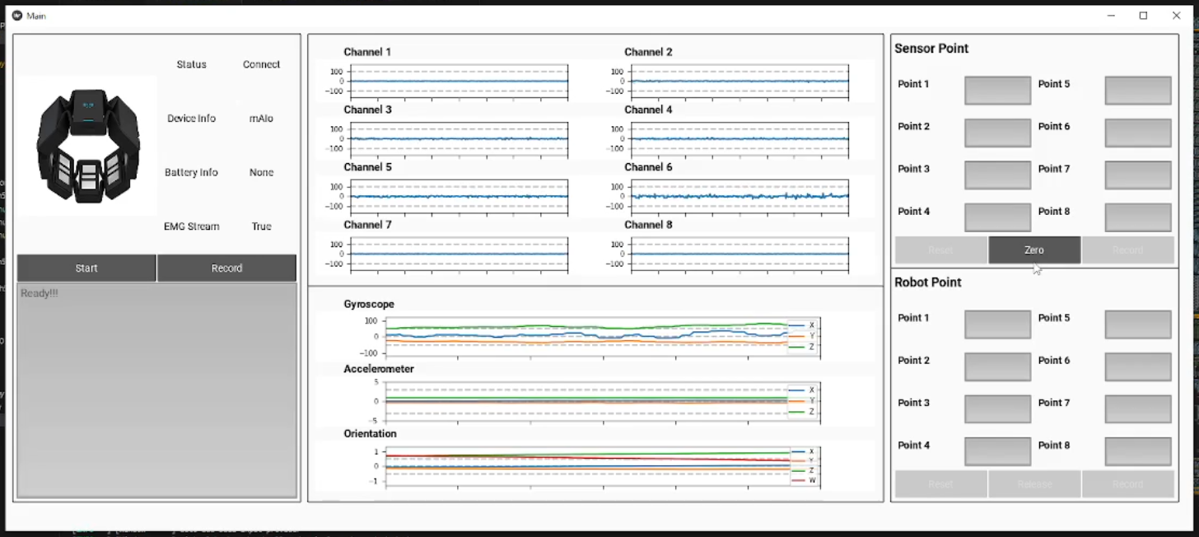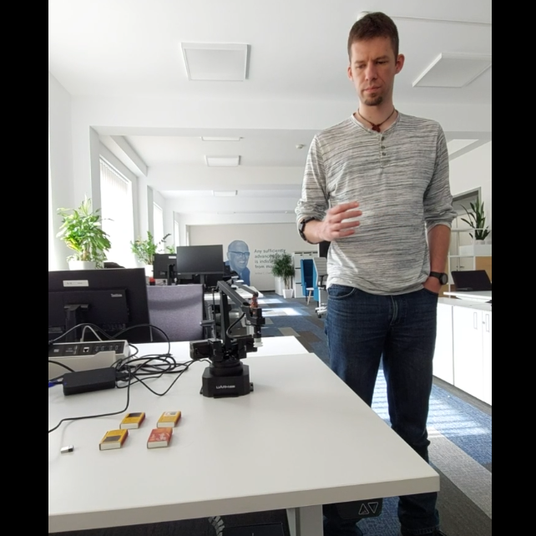

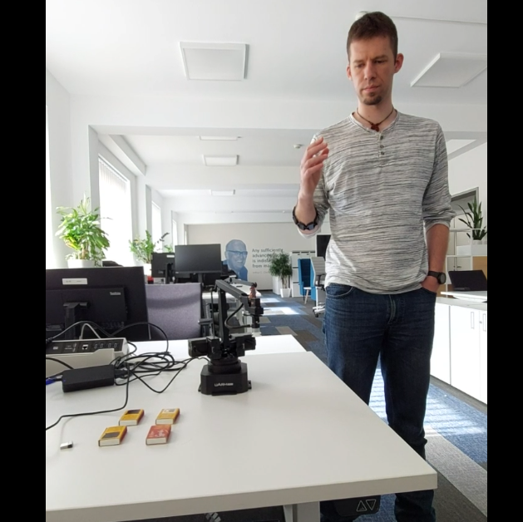

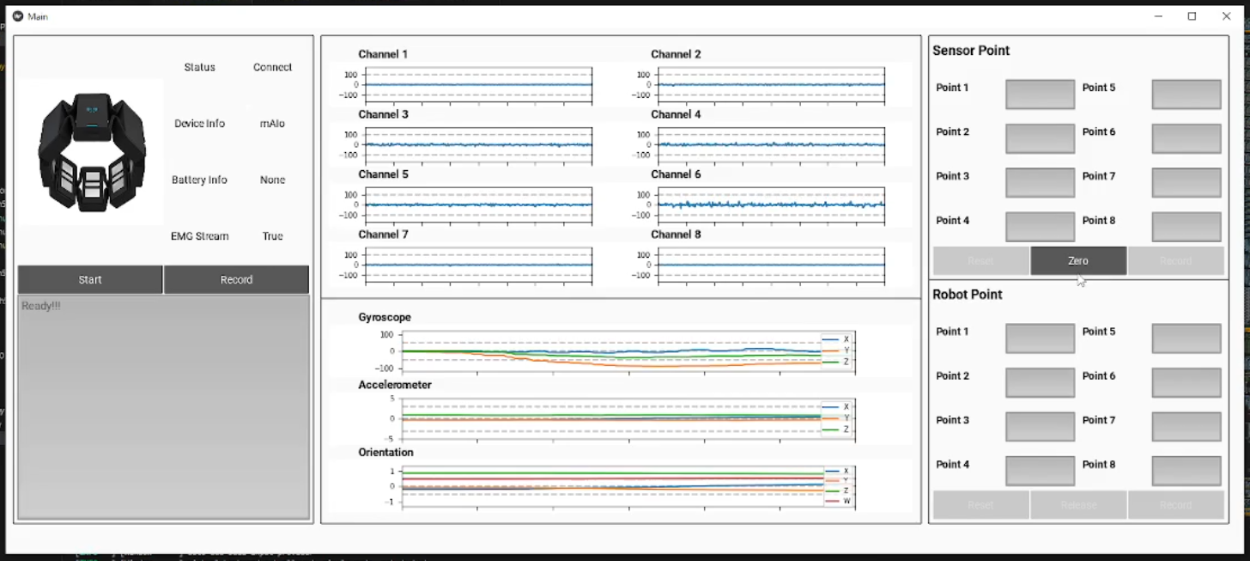

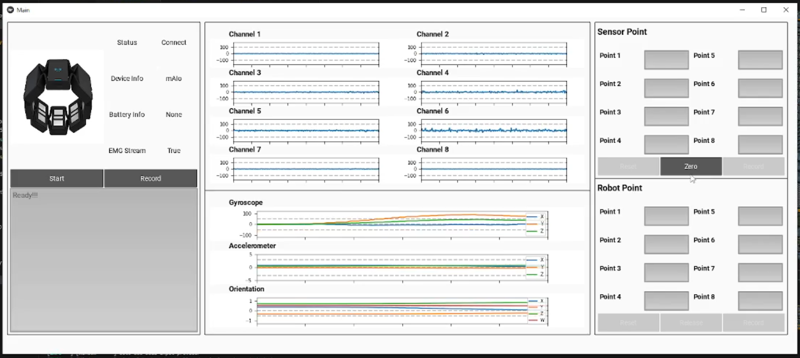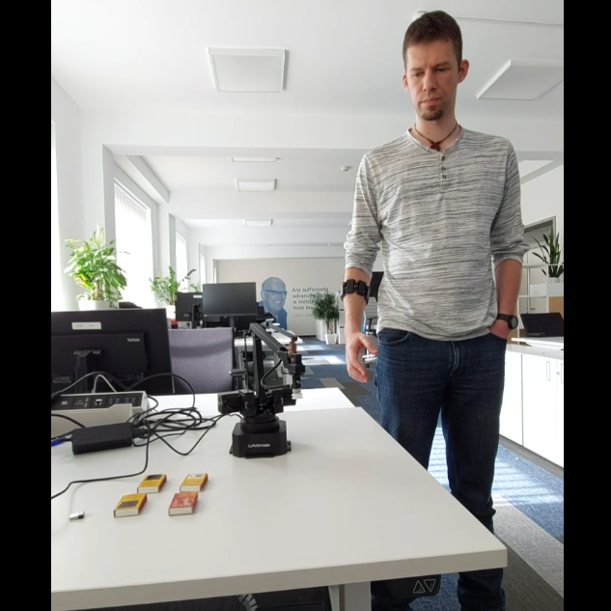

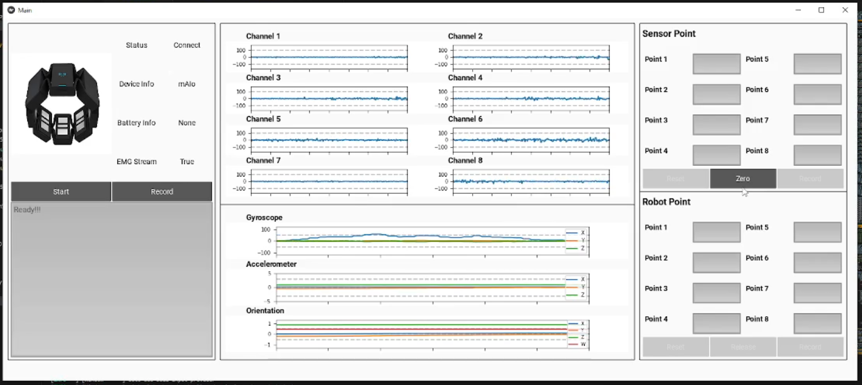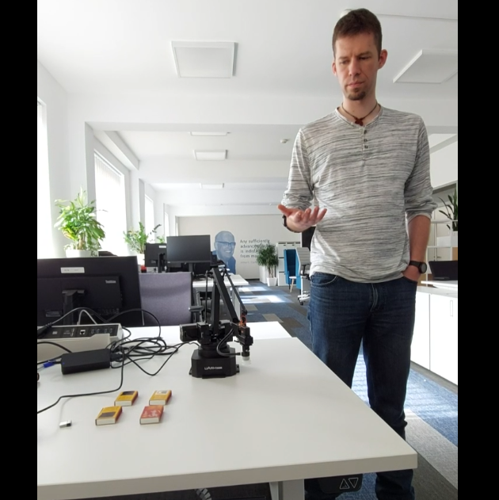

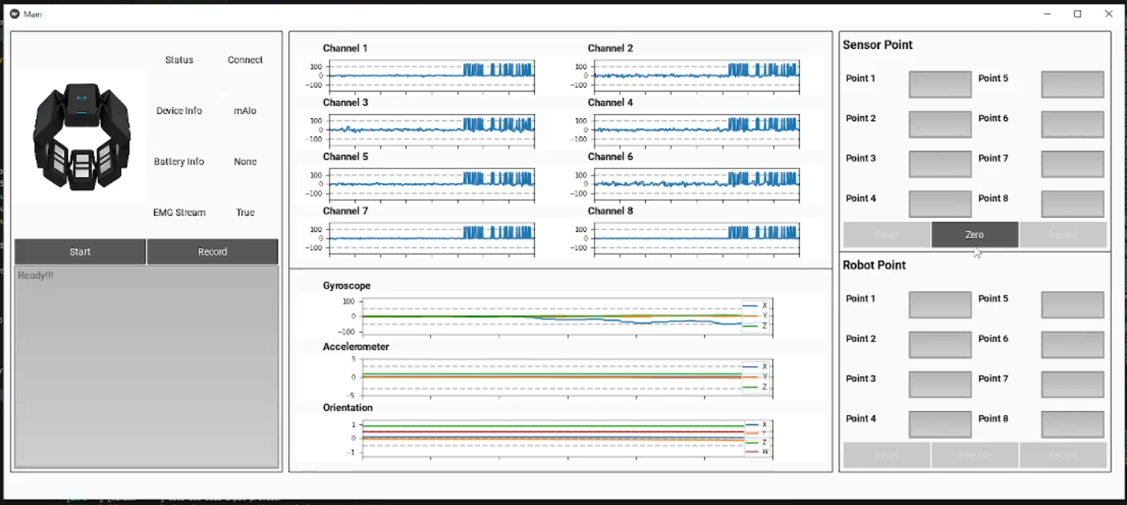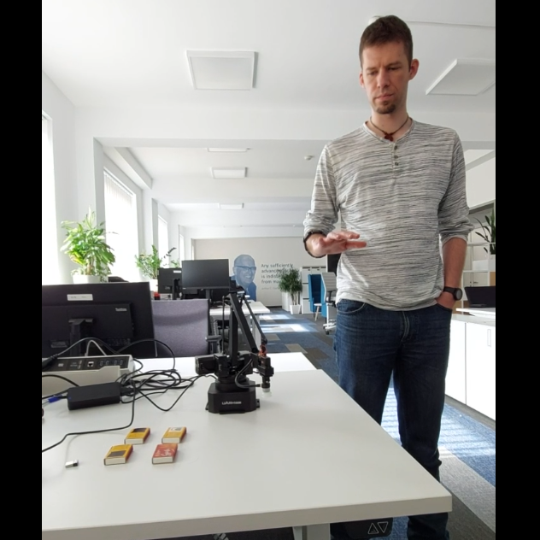

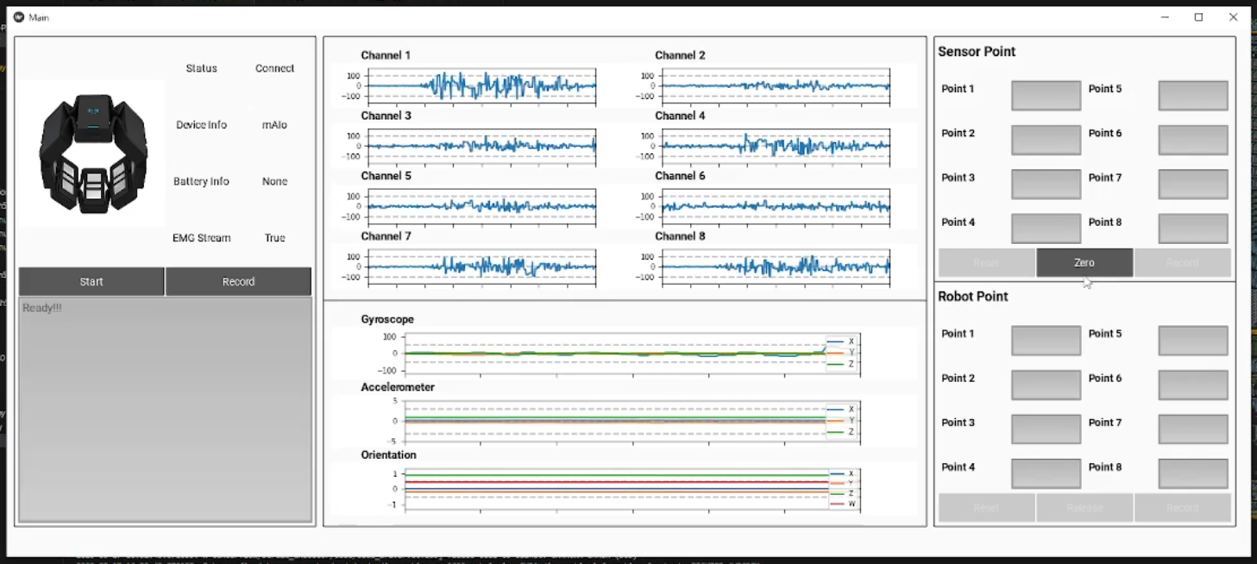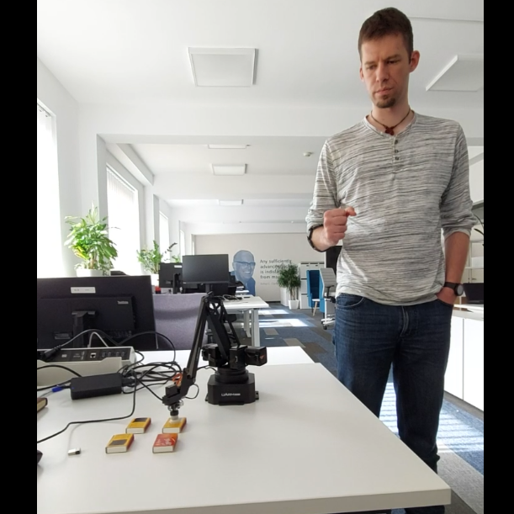

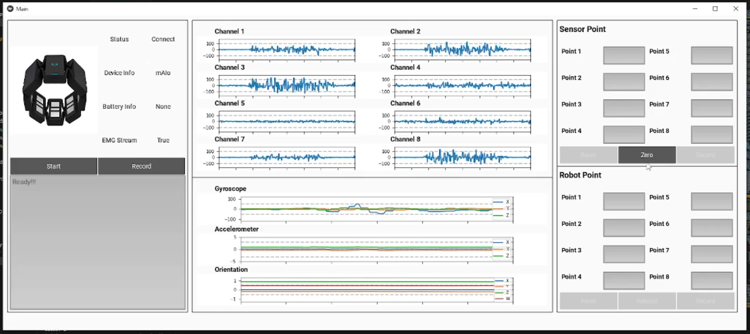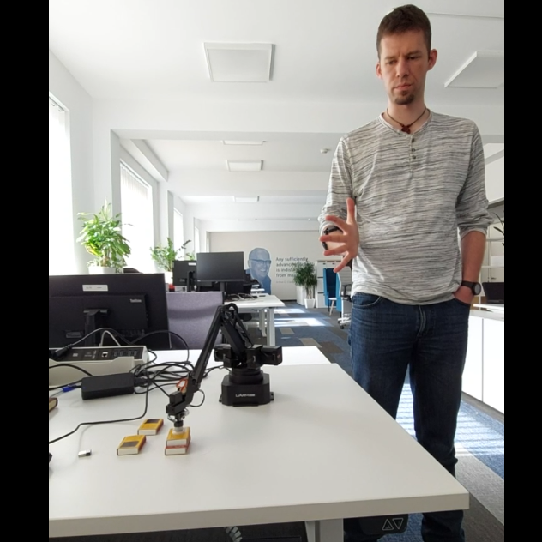



**Calibration Panel**

**EMG Signal**

**Myo Armband Status &  
Information Window**

**IMU Signal**

Figures 1 and 2 illustrate the model performance in training in the datasets with and without rectification. Figure 1 shows that the training and the validation accuracy in the dataset with rectification always increase following the number of epochs. On the other hand, the training and validation loss continuously decreases following the number of epochs. The model can get 95.83% training accuracy and 94.49% validation accuracy before the model stop training because the model starts to overfit at this point. Figure 1 shows that the training and the validation accuracy in the dataset without rectification continuously increase following the number of epochs. On the other hand, the training and validation loss continuously decreases following the number of epochs. The model can get 96.17% training accuracy and 94.52% validation accuracy before the model stops training because the model starts overfitting at this point.

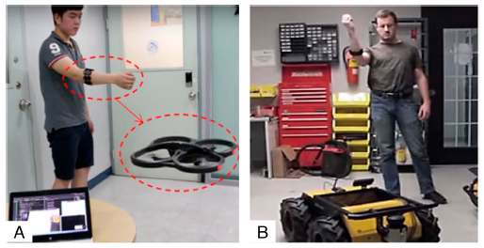

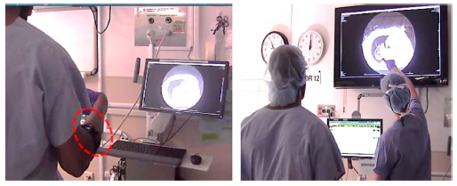

**C**